Project 20200914121258

Dashboard - Google Chrome

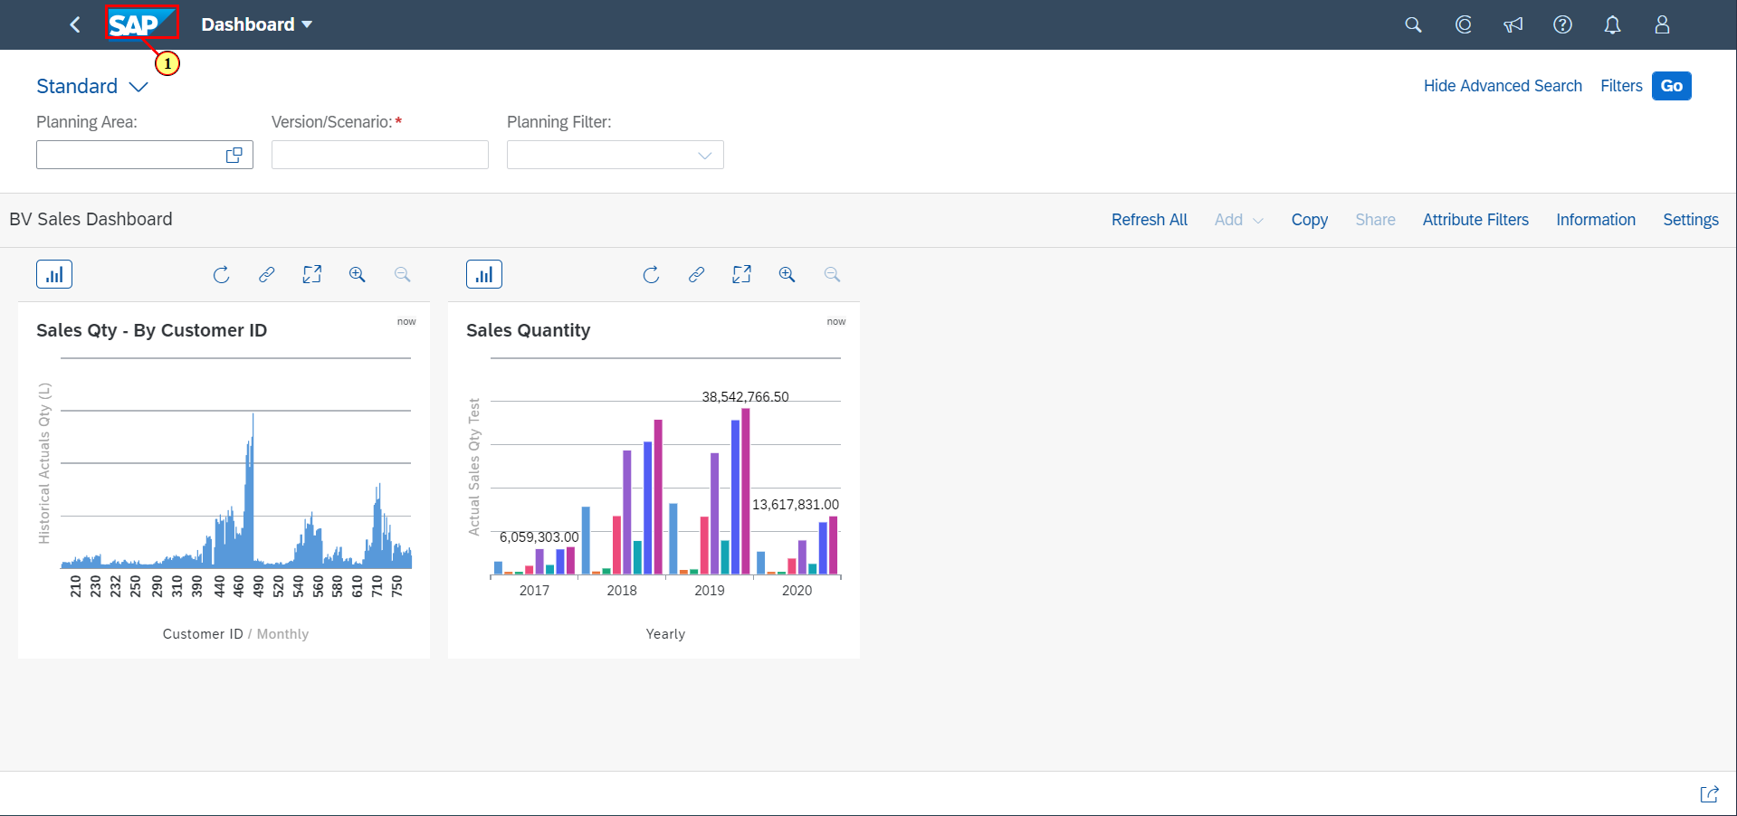

| Step | Action |
| --- | --- |
| (1) | Click on  **Home Page** |

Home - Google Chrome

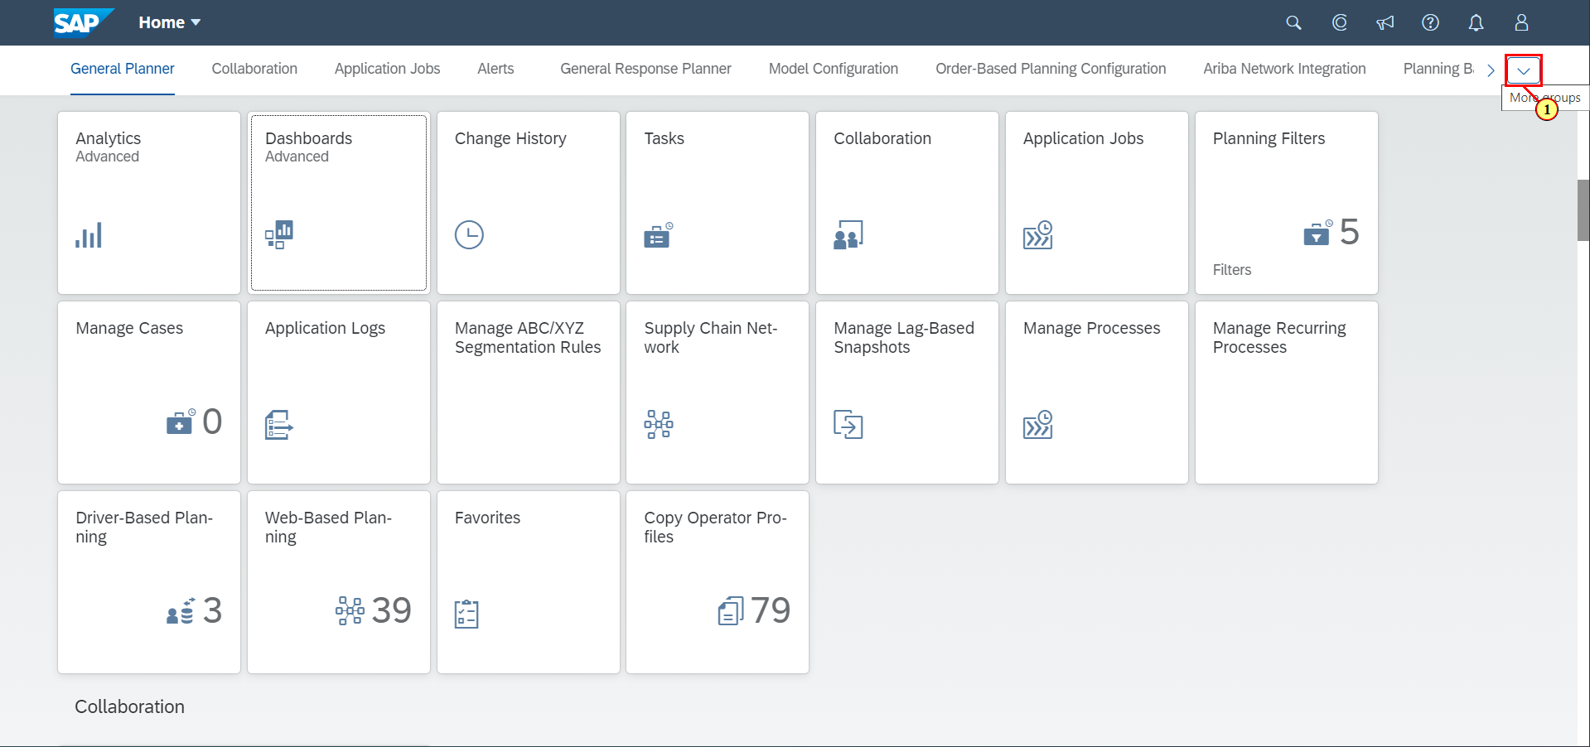

| Step | Action |
| --- | --- |
| (1) | Click on . |

Home - Google Chrome

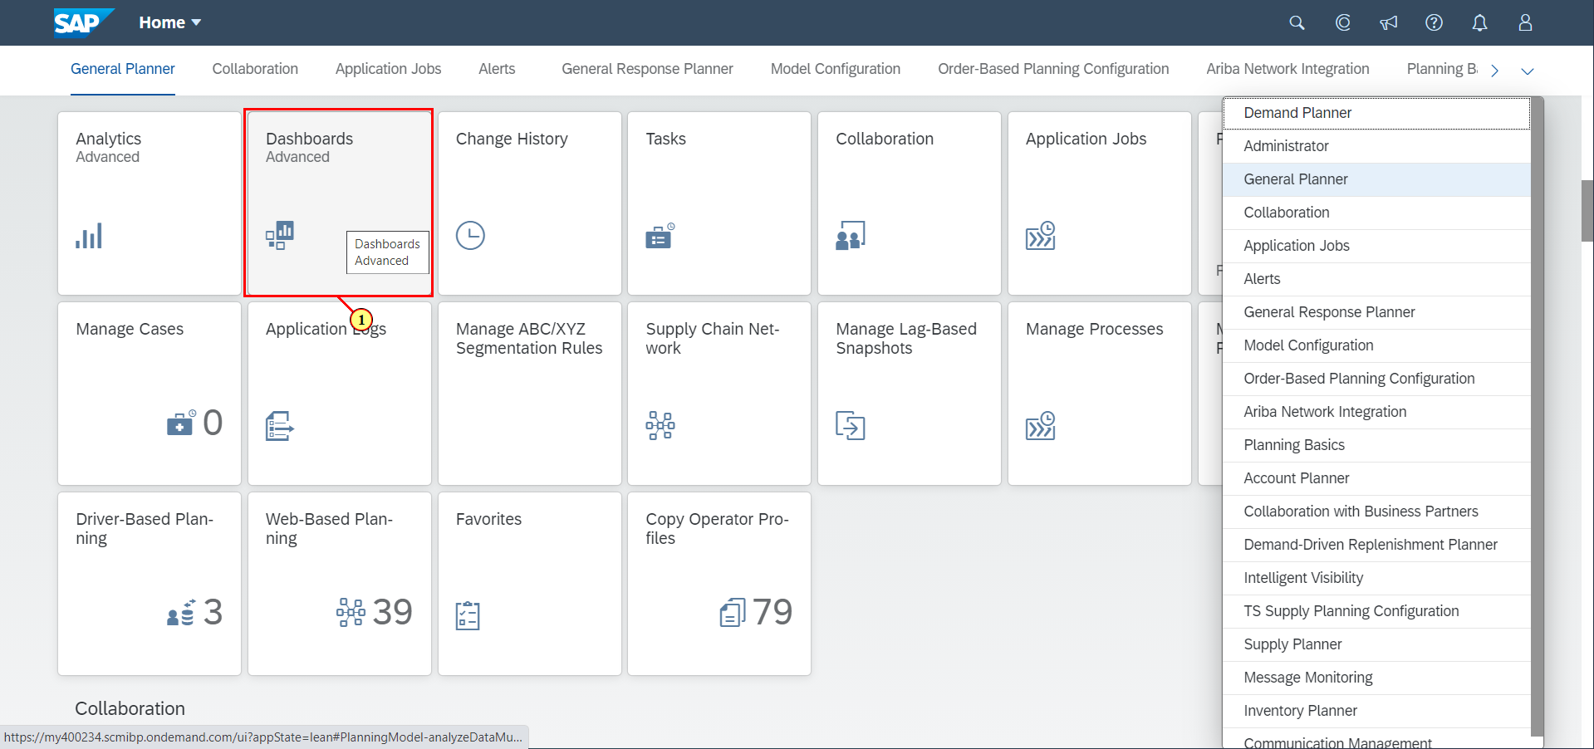

| Step | Action |
| --- | --- |
| (1) | Click on **Dashboards Advanced**. |

Dashboard List - Google Chrome

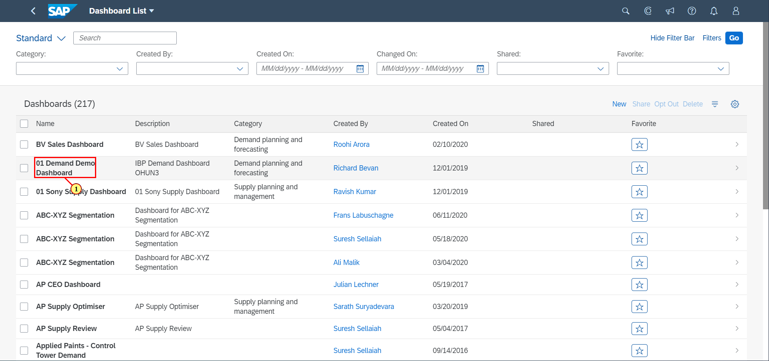

| Step | Action |
| --- | --- |
| (1) | Click on **01 Demand Demo Dashboard**. |

Dashboard - Google Chrome

